Experiment No. 2
Amplitude Shift Keying (ASK) Modulation and Demodulation

Object:
- To study and understand the principle of Amplitude Shift Keying modulation and demodulation
- To learn how to implement ASK modulation and demodulation using Matlab-Simulink.
- To evaluate the performance of ASK modulation and demodulation over AWAG channel.
Theory:
For long distance communication like communication with the aircraft, ship, and vehicle, the radio transmission is only the union mean. It is not possible to send the digital data directly over the antenna because the antenna of practical size work on very high frequencies, much higher than our data transmission rate.
To be able to transmit the data over antenna, we have to ‘modulate’ the signal’s phase; frequency or amplitude etc. is varied in accordance with the digital data. Modulation also allows different data streams to be transmitted over the same channel (transmission medium).
In digital communication, the modulating wave consists of binary (2-level) or an M-array (M-level) encoded version of data. The binary ASK system was one of the earliest forms of digital modulation used in wireless telegraphy. The level of amplitude can be used to represent binary logic 0s and 1s. In the modulated signal logic 0 is represented by the absence of a carrier and logic 1 is represented by the present of a carrier.

ASK Modulation
An M-array ASK modulated signal can be expressed as:
$$X_{ASK}\left(t\right)=A_{i}\cos\left(ω_{c}t+θ_{0}\right) 0≤t≤T, i=1,2……M$$
Where the amplitude A_{i} has M possible values (M levels), ω_{c} is the angular frequency and θ₀ the phase as a constant.
If the system uses a binary ASK modulation which also called On-Off keying (OOK) modulation or 2-ASK modulation, M=2 (A₁=0 and A₂=A), where A is an arbitrary constant.
Figure 1 shows Binary ASK modulation waveforms. There are sharp discontinuities shown at the transition points. These result in the signal having an unnecessarily wide bandwidth. Band limiting is generally introduced before transmission, in which case these discontinuities would be ‘rounded off’. The band limiting may be applied to the digital message, or the modulated signal itself. Figure 2 shows the structure of binary ASK modulator.
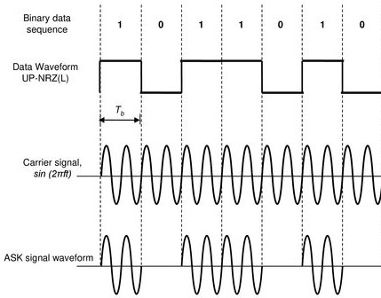
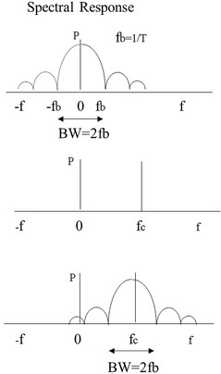

Figure 1 ASK modulation waveforms and their frequency domains

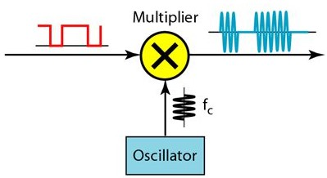
Bandpass Filter

Figure 2 Structure of ASK modulator

ASK Demodulation
The method of demodulation is an important factor in determining the selection of a modulation scheme. There are two types of demodulation which are distinguished by the need to provide knowledge of the phase of the carrier as follows:
- Coherent (Synchronous) ASK Demodulation
This demodulation scheme needs to realize the carrier phase. Coherent demodulation requires more complex circuitry, but has better performance and more effective as against the noise effect. Coherent demodulation System multiplies the ASK signal by the locally regenerated (replica) carrier with keeping on realization of the phase of the replica carrier signal, termed local oscillator, ‘locked’ to the carrier. The operation of keeping the phase of the replica carrier is difficult to be achieved. In general, Oscillators are sensitive to temperature, noise, and will gradually drift in frequency and phase. Figure 3a shows a block diagram of coherent ASK demodulator and each stage’s output waveforms. To explain the operation of coherent ASK demodulation, we expresses the operation through equation as follows:
we consider the input signal is ASK(t)=m(t)$cos⁡(2πf_{c}t)$, the local generated carrier c(t)=A_{c} cos(2πf_{c}t).
$$d\left(t\right)=ASK\left(t\right)*c\left(t\right)=m\left(t\right)\cos\left(2πf_{c}t\right)*A_{c}\cos\left(2πf_{c}t\right)$$
$$=A_{c}m\left(t\right)\cos^{2}\left(2πf_{c}t\right)=A_{c}m\left(t\right) \left(\frac{1+cos⁡(4πf_{c}t)}{2}\right)$$
$=\frac{A_{c}}{2}m\left(t\right)+\frac{A_{c}}{2}m\left(t\right)cos⁡(4πf_{c}t)$
After low pass filter,
$$\hat{d(t)}=\frac{A_{c}}{2}m\left(t\right)$$
- Incoherent (Asynchronous) ASK Demodulation
In contrast, Incoherent ASK demodulation scheme does not need to knowledge of the carrier phase and is sensitive only to the power of the signal, with ASK, the power is either present or not. This demodulation scheme requires simple and cheap circuitry, but has poorer performance and effective against the noise effect.
In Incoherent ASK demodulation, the ASK signal is passed to an envelope detector which considers as the simplest and cheapest method of demodulation. This device will produce an output as the outline of the signal and then the decision is made by the rest of system to be whether the signal is present or not. Figure 3b shows a block diagram of incoherent ASK demodulator and each stage’s output waveforms.
In the first case, coherent demodulator multiplies the ASK signal by the locally generated carrier, but in the second case the envelope of the ASK signal is detected via diode. In both cases the detector is followed by a low pass filter, which removes the residual carrier components, and a threshold circuit which squares the data signal as shown in Figure 3.
The main characteristics of ASK are:
- it is mainly used for radiotelegraphy,
- it requires not complex circuits,
- ASK is very sensitive to noise and disturbances and has limited application in data transmission (low bit rates up to 100 bps). That means it has a high possibility of error.
- the minimum spectrum BW of the modulated signal is higher than the bit transmission frequency Fb.
- the efficiency of transmission, defined as the ratio between Fb and Bw, is lower than 1
  - the modulation or symbol speed (Baud) is equal to the transmission speed Fb which slow.

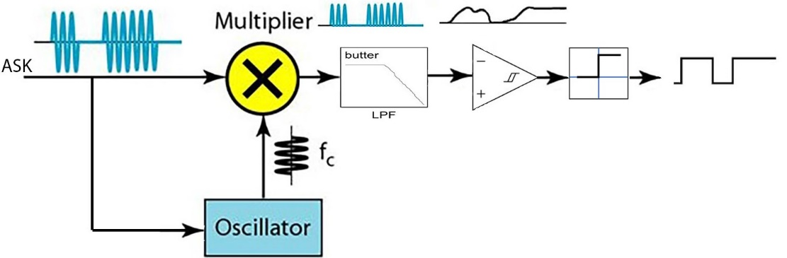

(a)

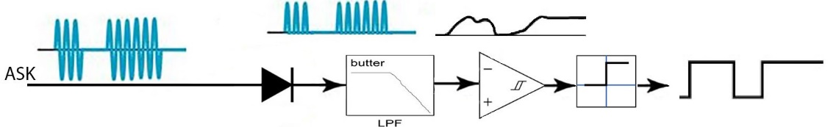

(b)
Figure 3 Binary ASK Demodulator (a) Coherent (b) Incoherent

Procedure
Part A: Simple ASK Modulator and Coherent Demodulator
- Implement the ASK modulator and demodulator shown in Figure 4.
- Set the parameters of all the signal generators where waveform is sine with the amplitude 1 V and frequency 4 Hertz. Select the units in Hertz and Use Simulation Time.
- Set the parameters of the Analog Filter Design as follows:
Design method: Butterworth, Filter type: Lowpass, Filter order: 8, Passband edge frequency(rad/sec): 30
- Plot the signals in each scope.
- What happened when you changed the cutoff (Passband edge) frequency to 10?

Figure 4 Simple ASK Modulator and Coherent Demodulator

Part B: Realistic ASK modulator and Coherent demodulator
1. Implement the Realistic Coherent ASK modulator and demodulator shown in Figure 5.
- Repeat the setting of the parameters of the components as shown in Part A.
- Set the parameters of Analog Filter Design (Mod) as follows:
Design method: Butterworth, Filter type: Bandpass, Filter order: 8, Lower Passband edge frequency(rad/sec): 0.16, Higher Passband edge frequency (rad/sec): 127
Notice: 1 Radian per second is comparative to 1/2π Hertz
- Set the parameters of AWAG channel as follows:
Input processing: Columns as channels, Initial seed: 67 (or any number)
Mode: Signal to noise ratio (SNR), SNR (dB):30, Input signal power (watts):1
- Plot the signals in each scope and record the error rate.
- What happened when you changed SNR (dB) of the channel to 10?

Figure 5 Realistic Coherent ASK Modulator and Demodulator
Part C: Realistic ASK Modulator and Incoherent Demodulator
- Implement the Realistic ASK modulator and Incoherent demodulator shown in Figure 6.
- The diode is represented by Positive linear transfer function (Poslin).
- Repeat the setting of the parameters of the components as shown in Part B.
- Plot the signals in each scope and record the error rate.
- What happened when you changed the cutoff (Passband edge) frequency of the lowpass filter to 20?

Figure 6 Realistic ASK Modulator and Incoherent Demodulator

Discussion
- From the result, explain the effect of AWAG channel on ASK signal.
- From the result, compare between coherent and incoherent demodulation of ASK signal.
- Explain disadvantages of ASK modulation system.
- Explain through equations what happen if there is a phase error θ_{c} between the transmitted ASK signal and local (replica) carrier signal in coherent ASK demodulator. Then what happen if θ_{c}=90º.
- Describe the importance of using Bandpass filter in ASK Modulator.
- Describe the importance of using LPF filter in ASK Demodulator.
- Why binary ASK modulation system is considered as a slow data-transmission system.

Model Solutions:
1. The effect of changing SNR (30 or 10) in Coherent demodulator is small or ignored, but the effect in Incoherent demodulator is so big for 30 and we removed the effect by reducing the cutoff frequency of analog lowpass filter.
2. The coherent demodulation is less sensitive to noise and disturbances than the Incoherent demodulator.
3. the Disadvantages of ASK signal are: (from above)
- ASK is very sensitive to noise and disturbances and has limited application in data transmission (low bit rates up to 100 bps). That means it has a high possibility of error.
- the efficiency of transmission, defined as the ratio between Fb and Bw, is lower than 1
  - the modulation or symbol speed (Baud) is equal to the transmission speed Fb which slow.

4. we expresses the operation through equation as follows:
we consider the input signal is ASK(t)=m(t)$cos⁡(2πf_{c}t)$, the local generated carrier c(t)=A_{c} cos(2πf_{c}t + θ_{c}).
$$d\left(t\right)=ASK\left(t\right)*c\left(t\right)=m\left(t\right)\cos\left(2πf_{c}t\right)*A_{c}\cos\left(2πf_{c}t+θc\right)$$
$$=m\left(t\right)\cos\left(2πf_{c}t\right)*A_{c} \left(\cos\left(2πf_{c}t\right)cos\left(θc\right)-\sin\left(2πf_{c}t\right)\sin\left(θc\right)\right)$$
$$=m\left(t\right)A_{c}(\left(\frac{1+\cos\left(4πf_{c}t\right)}{2}\right) cos\left(θc\right)-\frac{sin4πf_{c}t}{2}\sin\left(θc\right))$$
$$=\frac{m(t)A_{c}}{2}cos\left(θc\right)+\frac{m(t)A_{c}}{2}cos\left(4πf_{c}t\right) cos\left(θc\right)⁡-\frac{m\left(t\right)A_{c}}{2}sin4πf_{c}t sin⁡(θc)$$

After low pass filter,
$$\hat{d(t)}=\frac{m(t)A_{c}}{2}cos\left(θc\right)$$
If $θc={90}^{o}$
$$d(t)=-\frac{A_{c}m\left(t\right)}{2}sin⁡(4πf_{c}t)$$
After low pass filter,
$$\hat{d(t)}=0$$
Notice: to check our expression result, please, replace the signal generator in demodulator in Figure 5 by Sine wave and set its parameters as shown below.

- (from Above) There are sharp discontinuities shown at the transition points. These result in the signal having an unnecessarily wide bandwidth. Band limiting is generally introduced before transmission, in which case these discontinuities would be ‘rounded off’. The band limiting may be applied to the digital message, or the modulated signal itself.
- (from above) which removes the residual carrier components.

